KARMA AI AZURE:

* Create Windows 10 VM and also disk (64G)

ID:

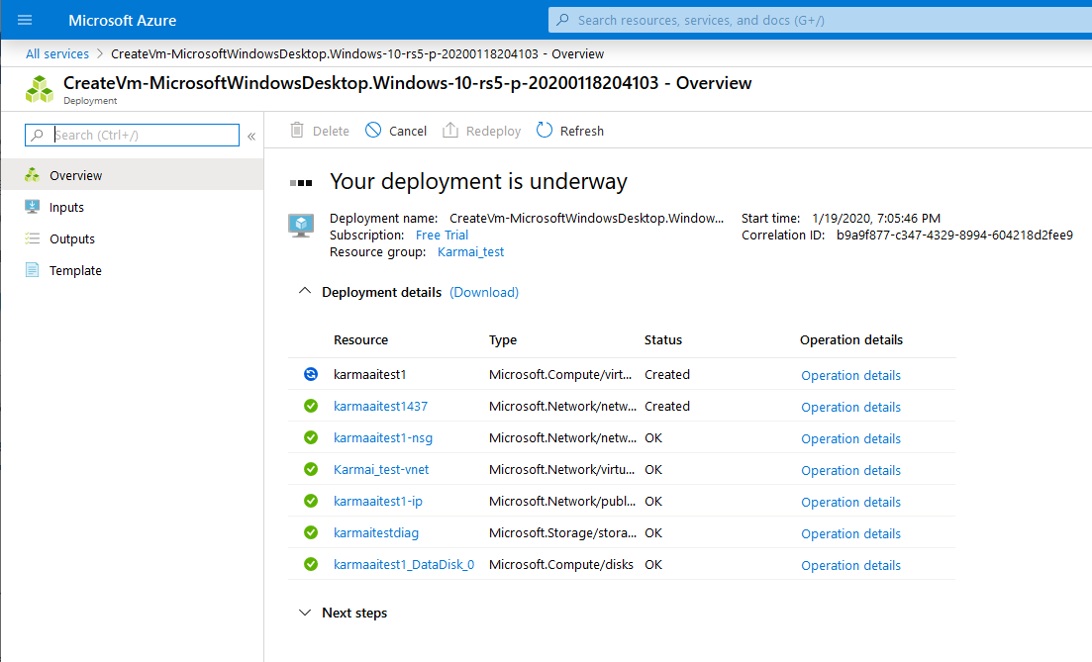

Based on spec here:

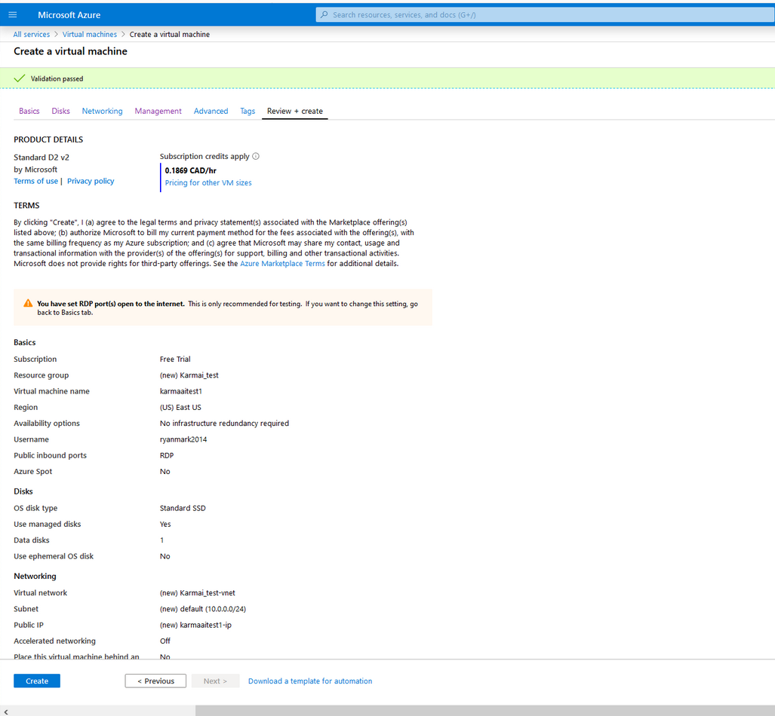

Resource group(

)

:

Karmai_test

Status

:

Running

Location

:

East US

Subscription(

)

:

Free Trial

Ctrl-C to copy

Copy to clipboard

Subscription ID

:

def95cc3-dfe7-44e9-87b0-4a8fea0aa1b5

Ctrl-C to copy

Copy to clipboard

Computer name

:

karmaaitest1

Operating system

:

Windows (Windows 10 Pro)

Ctrl-C to copy

Copy to clipboard

Size

:

Standard D2 v2 (2 vcpus, 7 GiB memory)

Ctrl-C to copy

Copy to clipboard

Azure Spot

:

N/A

Public IP address

:

52.168.9.70

Private IP address

:

10.0.0.4

Public IP address (IPv6)

:

-

Private IP address (IPv6)

:

-

Virtual network/subnet

:

Karmai_test-vnet/default

DNS name

:

Configure

Scale Set

:

N/A

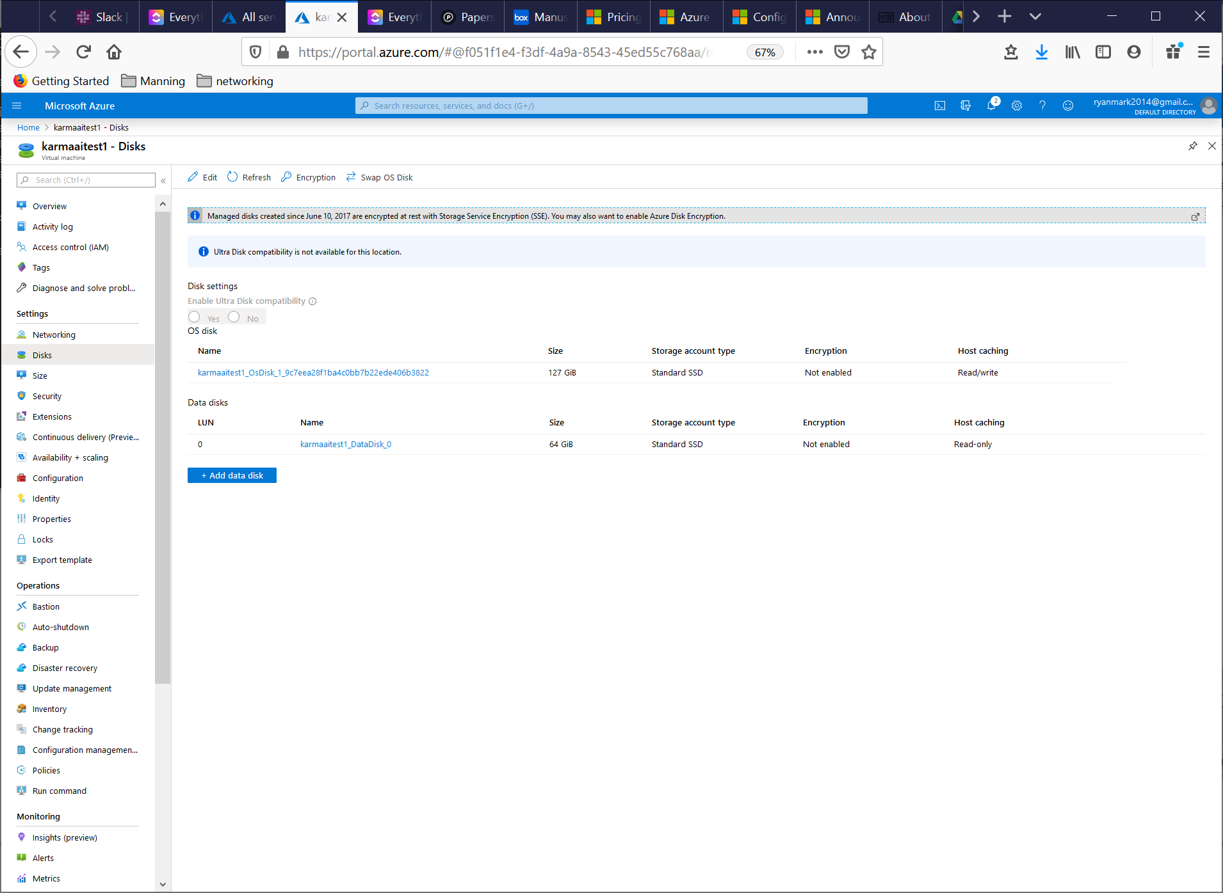

TO LOG ONTO VIRTUAL MACHINE

1. Download RDC file – REMEMBER TO FOLLOW TO GET ACCESS TO FILESYSTEM <http://geekswithblogs.net/hroggero/archive/2015/03/10/copy-files-from-you-local-computer-to-an-azure-vm.aspx>
2. Use correct azure vm credentials (not same as credentials to access azure portal)
   1. Virtual machine:
   2. Admin id: ryanmark2014

**Install**:

* Chrome (and synced)
* Firefox (and synced)
* Notepad++
* Python 3.8, replaced with Python 3.7 to avoid rasa install issue
  + Pip install pandas
* Rasa
  + Had to install Visual C++ tool builder for Rasa install to work

error: Microsoft Visual C++ 14.0 is required. Get it with "Microsoft Visual C++ Build Tools": <https://visualstudio.microsoft.com/downloads/>

* + - <https://visualstudio.microsoft.com/downloads/#build-tools-for-visual-studio-2019>
  + Did rasa init and validated it works
* Git (and pulled chatbot repo)
* Copied scripts from target directory to
* To get access to filesystem on my local machine, followed: <http://geekswithblogs.net/hroggero/archive/2015/03/10/copy-files-from-you-local-computer-to-an-azure-vm.aspx>)

GIT UPDATE FROM REPO:

git pull https://github.com/ryanmark1867/chatbot master

**FIXUPS HAD TO DO**:

* Pip install pandas
* Had to change script permissions in powershell to allow scripts to run <https://docs.microsoft.com/en-us/powershell/module/microsoft.powershell.core/about/about_execution_policies?view=powershell-7>
  + Set-ExecutionPolicy -ExecutionPolicy **Unrestricted**

All scripts are in default starting directory for powershell sessions C:\Users\ryanmark2014

1. Start ngrok:

.\Ngrok http 5005

& ".\ngrok_start.ps1"

1. Start rasa:

& ".\rasa_run_server.ps1"

1. Update webhook URL in Facebook dev
   * <https://developers.facebook.com/apps/750984582087384/messenger/settings/>
   * Messenger -> Settings –
   * Get https URL from Ngrok output

Need to update path to expose Python

* Path on laptop: C:\Users\ryanm\AppData\Local\Programs\Python\Python37\
  + And C:\Users\ryanm\AppData\Local\Programs\Python\Python37\Scripts\
* Path on VM: C:\Users\ryanmark2014\AppData\Local\Programs\Python\Python38-32\
  + And C:\Users\ryanmark2014\AppData\Local\Programs\Python\Python38-32\Scripts\
* With Python 3.8 Rasa install failed on tf 1.x dependency, so trying Python 3.7.6
* Path on VM: C:\Users\ryanmark2014\AppData\Local\Programs\Python\Python37\
  + And C:\Users\ryanmark2014\AppData\Local\Programs\Python\Python37\Scripts\

Pip install rasa (from <https://rasa.com/docs/getting-started/>) failed on

Collecting tensorflow~=1.15.0 (from rasa)